**SOUTHERN REGIONAL PLANNING PANEL**

|  |  |
| --- | --- |
| JRPP No | **2019STH001 DA** |
| DA Number | DA-2018/1638 |
| Local Government Area | Wollongong City |
| Proposed Development | Mixed use development – fourteen (14) storey building comprising of one hundred and two (102) residential units and eight (8) commercial tenancies over two (2) levels of basement parking |
| Street Address | 71-77 Kembla Street, WOLLONGONG  Lot 502 DP 845275 |
| Applicant/Owner | Applicant – ADM Architects; Owner – City Investments Pty Ltd |
| Number of Submissions | Initial notification period - six (6) submissions in objection to the proposal  Second notification period – 45 submissions in objection to the proposal |
| Regional Development Criteria | Clause 3, Schedule 4A of the Environmental Planning & Assessment Act 1979; general development over $30 million.  The applicant’s CIV estimate for the project is $43,270,000. |
| List of All Relevant s4.15(1)(a) Matters | * List all of the relevant [environmental planning instrument](http://www.austlii.edu.au/au/legis/nsw/consol_act/epaaa1979389/s4.html#environmental_planning_instrument)s: s4.15(1)(a)(i) –   State Environmental Planning Policies (SEPPs):   * SEPP No. 65 – Design Quality of Residential Apartment Development * SEPP (Coastal Management) 2018 * SEPP (Building Sustainability Index: BASIX) 2004 * SEPP No. 55 – Remediation of Land * SEPP (Infrastructure) 2007 * SEPP (State and Regional Development) 2011   Local Environmental Planning Policies:   * Wollongong Local Environmental Plan 2009   Other policies   * NSW Apartment Design Guide * Wollongong Development Contributions Plan 2018 * List any proposed instrument that is or has been the subject of public consultation under the Act and that has been notified to the [consent authority](http://www.austlii.edu.au/au/legis/nsw/consol_act/epaaa1979389/s4.html#consent_authority): s4.15(1)(a)(ii)   Nil of relevance to the proposal   * List any relevant [development control plan](http://www.austlii.edu.au/au/legis/nsw/consol_act/epaaa1979389/s4.html#development_control_plan): s4.15(1)(a)(iii)   Wollongong Development Control Plan 2009   * List any relevant planning agreement that has been entered into under section 7.4, or any draft planning agreement that a developer has offered to enter into under section 7.4: s4.15(1)(a)(iv)   Nil   * List any coastal zone management plan: s4.15(1)(a)(v)   Nil   * List any relevant [regulations](http://www.austlii.edu.au/au/legis/nsw/consol_act/epaaa1979389/s4.html#regulation): s4.15(1)(a)(iv) - Environmental Planning & Assessment Regulation 2000 Clauses 92, 93, 94, 94A, 288   Clause 92 - AS 2601 in respect of any demolition. |
| List all documents submitted with this report for the Panel’s consideration | Architectural plans by ADM Architects  Shadow analysis and Solar Impact Studies by ADM Architects  Landscape plans by Ochre Landscape Architects |
| List all documents submitted with the original report presented to the Panel for consideration on 27 November 2019 | Architectural plans by ADM Architects  Landscaping plans by Ochre Landscape Architects  Traffic documentation by Northrop Consulting Engineers  Arborist report by Allied Tree Consultancy  Stormwater plans and flooding analysis and response by Northrop Consulting Engineers  Planning documents by TCG Planning  Aboriginal Cultural Heritage Due Diligence Assessment by Biosis  Access Report – Accessible Building Solutions  Acoustic Report - Northrop Consulting Engineers Pty Ltd (Northrop) Acoustics  Contamination investigation - Douglas Partners |
| Recommendation | It is recommended that DA-2018/1638 be approved subject to the conditions contained within **Attachment 3.** |
| Report by | Theresa Whittaker, Senior Development Project Officer |

|  |  |
| --- | --- |
| **Summary of s4.15(1) matters**  Have all recommendations in relation to relevant s4.15 matters been summarised in the Executive Summary of the assessment report? | **Yes** |
| **Legislative clauses requiring consent authority satisfaction**  Have relevant clauses in all applicable environmental planning instruments where the consent authority must be satisfied about a particular matter been listed, and relevant recommendations summarized, in the Executive Summary of the assessment report?  *e.g. Clause 7 of SEPP 55 - Remediation of Land, Clause 4.6(4) of the relevant LEP* | **Yes** |
| **Clause 4.6 Exceptions to development standards**  If a written request for a contravention to a development standard (clause 4.6 of the LEP) has been received, has it been attached to the assessment report? | **Yes** |
| **Special Infrastructure Contributions**  Does the DA require Special Infrastructure Contributions conditions (S94EF)?  *Note: Certain DAs in the Western Sydney Growth Areas Special Contributions Area may require specific Special Infrastructure Contributions (SIC) conditions* | **Not Applicable** |
| **Conditions**  Have draft conditions been provided to the applicant for comment?  *Note: in order to reduce delays in determinations, the Panel prefer that draft conditions, notwithstanding Council’s recommendation, be provided to the applicant to enable any comments to be considered as part of the assessment report* | **Yes** |

**Assessment Report and Recommendation Cover Sheet**

Executive Summary

**Background & Reason for Report**

This application was reported to the Southern Regional Planning Panel (SRPP) for consideration on 27 November 2019. Determination of the application was deferred for the following further information:-

1 Amended architectural plans that relocate the plant room on Level 8 and review of parapet heights and leading edges at Levels 7 and 8 to improve solar access to the units in the north facing elevation of the IRT building on Stewart Street.

2 Amended shadow diagrams in elevation at 30 minute intervals that demonstrate the degree of improvement to the north acing elevation of the IRT building on Stewart Street arising from the amendments.

3 Amended architectural plans and landscape plan that provide for additional canopy tree planting on the Level 2 communal area and in the south-eastern corner of the site near the as meter. This will result in removal or relocation of car parking spaces R40 and R41 within the existing confines of the basement.

4 Details of how the existing mosaic can be relocated on site and incorporated into the building or common spaces.

5 On receipt of the amended plans, a further report can be prepared which addresses the above matters and includes:

a appropriate conditions including any modification of DA-2017/1462;

b modification to conditions to ensure landscape outcomes are successfully implemented.

The Panel advised that, once the information has been received, the Panel will determine the matter electronically.

This report provides some background information on the proposal and an analysis of the information supplied by the applicant in response to the Panel’s deferral.

**Reason for consideration by Southern Regional Planning Panel**

The proposal was referred to SRPP as it involves general development with a capital investment value (CIV) of more than $30 million. The CIV estimate for the project is $43.27 million.

**Proposal**

The proposal is a mixed use development comprising a fourteen (14) storey building housing 102 residential units and eight (8) commercial tenancies over two (2) levels of basement parking.

**Permissibility**

The site is zoned B3 Commercial Core pursuant to Wollongong Local Environmental Plan (LEP) 2009. The proposal is categorised as *shop top housing development* which is permissible in the zone with development consent.

**Consultation**

The proposal was notified on two (2) occasions in accordance with Council’s Advertising & Notification Procedures. In response to the initial notification, there were six (6) submissions in objection to the proposal including one (1) from Neighbourhood Forum 5. Following the submission of amended plans and additional information, the application was re-notified; there were 45 submissions received in response to this notification period.

**Main Issues**

The main issues arising from the assessment pertain to: -

* Flooding and stormwater management matters;
* Development departure in respect of building separation (Clause 8.6) of Wollongong Local Environmental Plan (LEP) 2009 to the eastern and northern boundaries;
* Apartment Design Guide (ADG) 3F Visual Privacy setback variations to the northern boundary for part of the building (L7 and above);
* Design quality. The proposal has been considered by the DRP twice (once post-lodgement) and required some changes. Revised plans were been submitted by the applicant responding to the recommendations of the Panel. These have been reviewed by the Chair of the DRP and were found to be acceptable;
* Public domain interface and street trees;
* Shared access, manoeuvring and servicing arrangements across the neighbouring site to the north;
* Heritage considerations;
* Wollongong DCP variations – setbacks; street frontage height; building depth/ bulk; overshadowing;
* Overshadowing impacts on the IRT building on the southern side of Stewart Street;
* Retention of the DMR mosaic attached to the existing building on the site.

The above issues were all discussed in length in the original assessment report which forms **Attachment 2** to this report.

**RECOMMENDATION**

It is recommended that DA-2018/1638 be approved subject to the conditions outlined in **Attachment 3**.

* 1. Proposal

The proposal was described in detail in the original report to the Panel of 27 November 2019. The following is a brief outline of the proposal only.

The proposal comprises the construction of a fourteen (14) storey building, comprising two levels of commercial tenancies and twelve (12) levels of residential apartments housing a total of 102 residential apartments, over two storeys of basement car parking.

The taller tower (Building A) is orientated predominantly towards the west and is positioned adjacent to Kembla Street while a seven (7) storey tower (Building B) occupies the eastern portion of the site and is generally orientated towards the north and south. The two elements are attached.

There are 4 commercial spaces on the ground floor and a further 4 at first floor level. The residential units occupy the remainder of the towers. There are communal open space areas on the rooftops; the primary COS is positioned on Level 2 while a secondary COS is located on the rooftop of Building B.

The residential car parking to be located within two dedicated basement parking levels accessed from Stewart Street (southern boundary). The commercial and residential visitor car parking will be provided in part on the ground floor level and within a mezzanine parking level and within part of Level 1, sleeved by commercial tenancies. Vehicular access will be obtained via two (2) separate driveways; the commercial car park will be accessed via a shared driveway positioned adjacent to the northern boundary of the site (shared with the neighbouring IMB bank headquarters under construction) and one adjacent to the eastern boundary servicing the residential car park. A right of carriageway has been registered to facilitate this shared access arrangement. This is illustrated in Figures 3 & 4 in **Attachment 2**.

Public domain works inclusive of paving and landscaping works are proposed within the site and adjacent footpath. The existing street tree (Brushbox) on the Kembla Street frontage will be retained and the design of the building will accommodate this tree.

Demolition of all structures on Lot 502 was approved under DA-2017/1462; this included the demolition of the former Department of Main Roads (DMR) building and the removal of vegetation within that site.

The site is situated within a medium flood risk precinct which has necessitated raising the ground floor level of the building for flood mitigation reasons.

The plans form **Attachment 1** and include rendered photomontages.

* 1. Background

*Relevant Development History*

DA-2017/1462: Demolition of all structures, and the construction of a seven (7) storey office building for IMB bank with two basement car parking levels for 89 car parking spaces – approved by the SRPP on 27 June 2018. This consent mainly relates to the lot to the immediate north of the site, however approved a right of carriageway with shared substation and access arrangements, a temporary car park and retaining structures etc. within the subject site along with the demolition of the existing structures within the subject site. The two developments will share the common driveway and manoeuvring areas which cross the common boundary between the sites. This consent has been enacted.

* 1. Site description

The site comprises a single allotment situated at the corner of the intersections of Kembla and Stewart Streets, Wollongong, with an area of 3350sqm, as depicted in Figure 1:

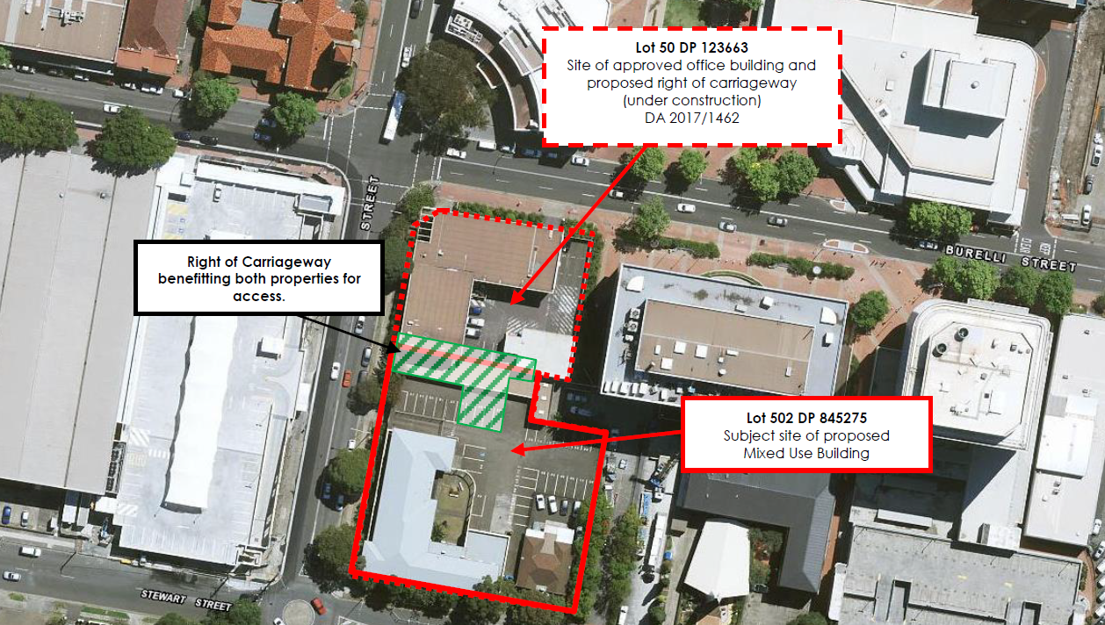

**Figure 1** – aerial photograph identifying the subject site, outlined with the red dashed line (source: SEE prepared by TCG Planning).

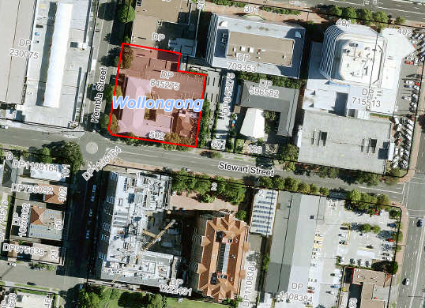

IRT Howard Court

IRT Parkside

**Figure 2** – aerial photograph identifying the subject site (outlined in red) and the IRT Parkside and Howard Court developments to the south

The site is legally identified as Lot 502 DP 845275. Land to the immediate north of the site is owned by IMB Ltd and has approval for a 7 storey office building which is currently under construction (DA-2017/1462).

The site is currently occupied by a two storey commercial building (which was formally occupied by Mission Australia), a separate single storey building and associated car parking. Consent has been granted for the demolition of these buildings and all vegetation under DA-2017/1462.

The site is located within the B3 Commercial Core.

A more detailed site description, aerial photographs of the site and locality, zoning extract and a copy of the deposited plan are provided in the original report to the SRPP which forms **Attachment 2** to this report.

* 1. DEFERRAL MATTERS

The Panel deferred determination of the development application pending the following information:

**1 Amended architectural plans that relocate the plant room on Level 8 and review of parapet heights and leading edges at Levels 7 and 8 to improve solar access to the units in the north facing elevation of the IRT building on Stewart Street.**

*Applicant’s response:*

In response to the above point, the applicant has submitted amended architectural plans which have been designed to reduce the extent of overshadowing impact resulting from the proposed development on the north-facing units of the IRT building. The plans incorporate the following changes to the plans:-

* The plant room on Level 8 of Building B has been removed
* The setbacks from the southern boundary to parts of Levels 6 and 7 of Building B have been increased. The solid balustrades on the eastern-most balcony of Level 6 has been removed and setback to Level 7 from the southern boundary has been increased from a minimum of 4.42m to 5.15m.
* The relevant elevations and sections have been amended to reflect the above plan amendments

The applicant has advised that each of the above changes have brought about reductions in the extent of overshadowing projected to occur on the IRT Parkside building to the south. The extent of that improvement is discussed below.

**2 Amended shadow diagrams in elevation at 30 minute intervals that demonstrate the degree of improvement to the north facing elevation of the IRT building on Stewart Street arising from the amendments.**

Detailed discussion on the issue of overshadowing was provided in Section 2.3.1 of the original report to the SRPP. The IRT ‘Parkside’ building and adjacent IRT ‘Howard Court’ building are the only residential properties that will be affected by overshadowing as a result of the proposed development. Howard Court will be overshadowed from 1pm on 21 June. IRT Parkside will be more significantly overshadowed. The below diagram (supplied by the applicant) identifies each of the relevant components of the IRT Parkside building which are discussed below in relation to solar access:

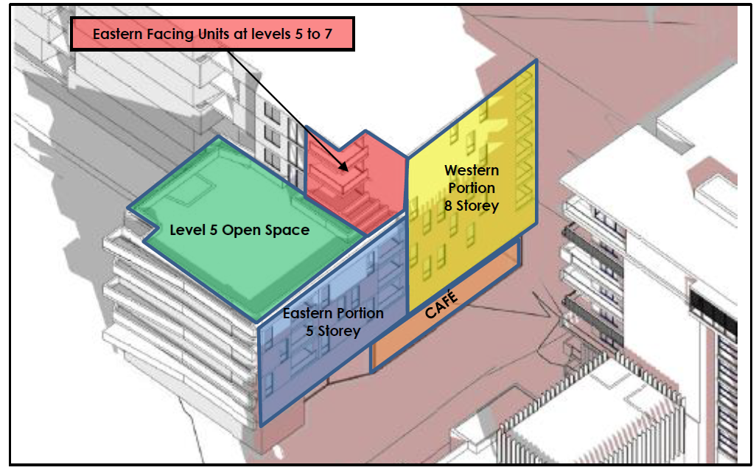

**Figure 3** – IRT Parkside building – provided by TCG Planning

As illustrated above, the ‘Parkside’ building comprises two linked elements being an 8 storey west-facing block closest to the intersection of Stewart and Kembla Streets. This section is occupied by residential units on Levels 2-7 generally oriented to the east/west and south; and a ground floor café along the Stewart Street frontage. The second portion comprises a 5 storey north-facing block with frontage to Stewart Street – this is occupied by residential units at Levels 2-4 oriented to the north or south. There is also a communal open space located at Level 5 in this eastern section of the building.

The shadowing impacts of the development as originally conceived can be summarised as follows:-

* The main seating area of the ground level café will receive 3 hours of sunlight in mid-Winter (from 12pm onwards).
* The Level 5 communal open space will receive 3 hours of sunlight in mid-Winter (9am- 12pm).
* The primary living room windows and balconies of the units in the 8 storey section of the building will receive 3 hours of sunlight, due to their western orientation.
* There are three (3) east-facing units at Levels 5-7 of the building; these are highlighted pink on Figure 3. The floor plan and window placement of these units varies slightly but is generally as follows:

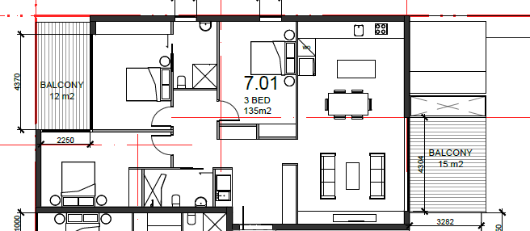

As per the above floor plan, these units have east-facing balconies and living room windows oriented over the L5 communal open space. Bedroom windows are generally located on the northern façade of the building (except one narrow secondary living room window at Level 5) and there are balconies and windows on the western end of these units. These units receive sunlight between 9am and approximately 10.30am and then from around 12pm onwards. It is noted that whilst afternoon sun to the eastern balcony is impacted by the proposed development, the ‘Parkside’ building itself overshadows such spaces in the afternoon period. At this time the west-facing windows and balconies will receive sunlight.

* Five (5) of the six (6) north-facing units within the lower, eastern portion of the building (highlighted blue in Figure 3) will not receive the required 3 hours of sunlight on June 21. Specifically, on L4 in this portion of the building, the majority of this level will be clear of shadow at 9am, with the living room and balcony of the eastern unit receiving sunlight through until approx. 11.30am. The balcony and primary living room window of the western unit will receive sunlight between 9am and 10.30am and will again receive sunlight between 1.30pm and 3pm. The living room and POS of the units at Level 4 in the eastern portion of the building will receive between approximately 2.5 to 3.0 hours of sunlight on June 21. On Level 3, the living room and POS of the eastern unit will receive sunlight between approximately 9.30am - 11.30am and between approximately 2.30pm - 3.00pm. The balcony and primary living room window of the western unit will receive sunlight between approximately 1.30pm - 3.00pm. Hence, the living room and POS of the units at Level 3 in the eastern portion of the building will receive between approximately 1.5 to 2.5 hours of sunlight on June 21. On Level 2, the living room and POS of the eastern unit will receive sunlight between approximately 2.30pm and 3.00pm. The balcony and primary living room window of the western unit will receive sunlight between approximately 1.30pm - 3.00pm. Hence, the living room and POS of the units at Level 2 in the eastern portion of the building will receive between approximately 0.5 to 1.5 hours of sunlight on June 21.
* The ‘Howard Court’ building (eastern portion of the IRT site, located to the south-east of the site) will be overshadowed after 1pm and will receive at least 3 hours of sunlight in the morning period in mid-Winter.

*Applicant’s response to SRPP deferral:*

The applicant has provided revised plans as discussed above.

The applicant has also provided shadow diagrams and solar impact analysis diagrams in elevation at 30 minute intervals that illustrate the overshadowing impact of the proposal as revised; these form part of **Attachment 1** to this report.

The diagrams demonstrate the degree of improvement to solar access to the north-facing elevation of the IRT Parkside building arising from the plan amendments, with the red shaded parts of the diagram indicating where improvements have occurred – that is, the red hatch indicates shadow previously forecasted to occur but now removed as a result of the plan amendments.  The applicant indicates that the improvements have been achieved with the implementation of the plan changes suggested by the Panel under point 1 of the SRPP deferral, including the removal of the plant room at Level 8 and adjusting the leading edge of the building at Level 7. Some minor changes at Level 6 also gave rise to some improvements.



Figure 3 is reproduced again to aid the interpretation of the solar access discussion. The solar access diagrams indicate that there is no change to solar access to the ground floor café (orange), eastern facing units of Levels 5 to 7 (red), and marginal change to the western portion of the building (yellow), though this section of the building already received more than sufficient sunlight. The units that most benefit from the plan revisions in terms of improved solar access are those located within the blue section (eastern portion, 5 storey).

The typical floor plan for the eastern (blue) part of the building is as follows:-

|  |
| --- |
| **Levels 2 & 4 floor plans** |
|  |
| **Level 3 floor plan** |
|  |

**Figure 4**: Levels 2, 3 & 4 floor plans, eastern portion IRT Parkside building.

The plan revisions have reduced the extent of overshadowing impacts on the IRT Parkside building for parts of the day; this is summarised as follows:-

* At 9am – there is a slight reduction in overshadowing of the L4 eastern-most unit (blue); improved solar access to balconies L5 (blue); removal of L8 plant room has reduced shadow to L4 western units (yellow) all north-facing windows on this level will benefit from some improved solar access.
* At 9.30am - improved solar access to central balcony L4 (blue); removal of L8 plant room has reduced shadow to L5 western units (yellow) 2 central north-facing windows on this level will benefit from some improved solar access.
* At 10am - reduction in overshadowing unit L3 windows and central balcony (blue); improved solar access to 1 window L3 in yellow section.
* At 10.30am – improved solar access to both balconies on L3 (blue) and the windows of the north-facing units on that level (blue).
* At 11.00am – improved solar access to eastern balcony on L2 (blue) and the windows of the north-facing units on that level (blue).
* At 11.30am – improved solar access to eastern balcony on L2 (blue) – this balcony will receive full sun at 11.30am.
* 12pm – 1pm - no change.
* At 1.30pm - minor reduction in overshadowing of rooftop communal open space eastern portion of Parkside (green).
* At 2pm – no change.
* At 2.30pm – minor improvement to solar access to the L4 eastern-most unit (blue) north-facing window.
* At 3pm – no change.

On the basis of the above analysis and that previously undertaken, five (5) of the six (6) north-facing units within the lower, eastern portion of the building (highlighted blue in Figure 3) will not receive the required 3 hours of sunlight on June 21. Each of the units within that portion of the building are discussed individually below:

*Level 4*

The living room and POS of the units at Level 4 in the eastern portion of the building will receive between approximately 2.5 to 3.0 hours of sunlight on June 21.

* + *L4 eastern unit -* the majority of this level will be clear of shadow at 9am, with the living room and balcony of the eastern unit receiving sunlight through until after 11.30am.
  + *L4 western unit* - The balcony and primary living room window of the western unit will receive sunlight between 9am and 10.30am and will again receive sunlight between 1.30pm and 3pm.The shadow diagrams indicate that overshadowing of the balcony and windows is reduced (as a result of the plan revisions) at 9am and 9.30am.
* *Level 3*
  + *L3 eastern unit* - the living room and POS of the eastern unit will receive sunlight between approximately 9.30am - 11.30am and between approximately 2.30pm - 3.00pm.
  + *L3 western unit* - the balcony and primary living room window of the western unit will receive sunlight between approximately 9.45am and 10.30am and 1.30pm - 3.00pm. Hence, the living room and POS of the units at Level 3 in the eastern portion of the building will receive between approximately 1.5 to 2.5 hours of sunlight on June 21. There is an improvement to solar access to this unit’s window and balconies at 10am and 10.30am as a result of the plan revisions.
* *Level 2*

The units on Level 2 of the IRT Parkside building are those most vulnerable to overshadowing given that they are at a lower elevation. Both of the units will receive less than 2 hours of sun on 21 June.

* + *L2 eastern unit* - the living room and POS of the eastern unit will receive sunlight between approximately 11am – 11.30am and 2.30pm and 3.00pm. It is noted that there is an improvement to solar access resulting from the plan revisions at 11am and 11.30am, with the balcony receiving sunlight when it previously was in shadow at this time.
  + *L2 western unit* - the balcony and primary living room window of the western unit will receive sunlight between approximately 1.30pm - 3.00pm. There is no improvement in the solar access to this unit as a result of the plan revisions.

Hence, the living room and POS of the units at Level 2 in the eastern portion of the building will receive between approximately 0.5 to 1.5 hours of sunlight on June 21.

*Discussion on DCP requirements*

In terms of the applicable development controls, Clause 6.9 of Chapter D13 of Wollongong Development Control Plan (DCP) 2009 states that new development must have regard to the existing and proposed level of sunlight which is received by living areas and private open space areas of adjacent dwellings; and that adjacent residential buildings and their public spaces must receive at least 3 hours of direct sunlight between 9am – 3pm on June 21.

The objective of Clause 6.9 is to “minimise the extent of loss of sunlight to living areas and private open space areas of adjacent dwellings.” The Clause requires:

* The design of the development must have regard to the existing and proposed level of sunlight which is received by living areas and private open space areas of adjacent dwellings.
* Adjacent residential buildings and their public spaces must receive at least 3 hours of direct sunlight between 9.00am and 3.00pm on 21 June.
* In areas undergoing change, the impact of overshadowing on development likely to be built on adjoining sites must be considered, in addition to the impacts on existing development.

*Applicant’s Justification*

The applicant provided the following justification in relation to the units which will not receive the required full 3 hours of solar access on 21 June:-

“It is considered that the level of overshadowing is acceptable for the following reasons:

* The subject site is located within an inner city location containing increasingly high-density development. The site has a 48m permissible building height, and the north/south relationship of the site to the Parkside development will inevitably result in a level of overshadowing, even if a lower building was proposed. Further, it is noted that the proposed development essentially mirrors the ‘Parkside’ building located directly to the south in terms of stepping down in height from the higher building located in the corner position. The proposed lower building on the eastern façade allows for greater sunlight access to the lower levels of the ‘Parkside’ building to the south.
* Whilst a number of units within the Parkside development will not achieve the 3 hours of sunlight specified in WDCP 2009, it is noted that 3 of the 6 northern facing units at Levels 2-4 of the building will receive a minimum of 2 hours of sunlight on June 21, which is the accepted standard for sunlight access into new developments under the Apartment Design Guide.
* Whilst the 3 eastern facing units at Levels 5-7 of the building do not provide the required 3 hours, it should be noted that the ‘Pioneer Place’ (Parkside) building itself overshadows the eastern facing units in the afternoon period.

In summary, it is considered that the level of sunlight access obtained by the IRT development is reasonable in an inner city, high density context. The permitted 48m height and the site’s north/south orientation will inevitably result in a level of overshadowing, however the level of overshadowing created by the proposed development is less than that which would occur if a 48m high building extended along the full frontage of the site. Whilst the northern orientation of a number of apartments in the Pioneer Place development (Parkside) will inevitably experience a level of overshadowing, it is noted that all units within the Pioneer Place (Parkside) development will continue to receive some sunlight on June 21, with the majority of units on the northern façade of the building continuing to receive a minimum of 2 hours of sunlight to their main living room window and balcony on June 21. Accordingly, Council support for the development in its current form is sought.”

*Planning Commentary:*

The plan revisions made have in part improved solar access to those units within the eastern portion of the IRT Parkside building which is most affected by overshadowing from the proposed development. The detailed shadow diagrams provided indicate that the changes to Levels 6, 7 and 8 of Building B in the proposal have brought about some improvements in solar access to at least 4 of the 6 units.

Each of the 75 units within the IRT Parkside building will receive some sunlight, however the development will impact on solar access to the north-facing units within that development, particularly those units in the lower, eastern portion of the building (highlighted blue in Figure 3) – these units will not receive the required 3 hours of sunlight on June 21 however as noted in the above analysis, solar access has been improved to 4 out of 6 of these units with the plan revisions made.

The IRT Parkside building was the subject of a 2014 development application and was assessed with regard to SEPP 65 and the (then) Residential Flat Design Code (RFDC). The assessment of that building indicates that 73% of the 75 units within the building would achieve 2 hours of solar access in mid Winter between 9am and 3pm (which was compliant with the Residential Flat Design Code at the time and consistent with the current requirements for solar access in 4A of the Apartment Design Guide). When factoring the overshadowing impact of the proposed development, this number will change only marginally, i.e. 70.33% of the units will continue to receive compliant solar access as per the requirements of the Residential Flat Design Code. Overall solar access to the IRT Parkside Development, measured in terms of compliance with the solar access provisions in the Apartment Design Guide (ADG), will remain compliant post construction of the subject development.

The RFDC and ADG provide for a less stringent requirement on solar access than the DCP which stipulates that a minimum of 3 hours sunlight between 9am and 3pm in mid winter be achieved. As such, there remains a variation in respect of Clause 6.9 of Chapter D13 of the DCP which, on balance is considered to be acceptable in this instance. The following circumstances of the case are relevant considerations when arriving at that view:-

* The subject site is located immediately north of the IRT Development and consequently will cast shadows in that direction.
* The zoning of the site is B3 Commercial Core whereas the zoning of the IRT site is B4 Mixed Use. There is a significantly greater allowable height permitted on the subject site (48m) and much greater floor space ratio (FSR) than that permitted on the southern side of Stewart Street. The development complies with the height and FSR standards.
* In particular it is noted that the eastern-most building (Building B) is significantly lower than the allowable height limit which is in part to ensure that overshadowing impacts are not excessive.
* The proposed building is setback from the two street frontages and from the eastern side boundary which significantly assists in reducing overshadowing impacts on IRT Parkside.
* The additional changes made as suggested by the SRPP have improved solar access to some units.
* As noted above, 2 hours of solar access in mid Winter to residential units is acceptable under the provisions of the ADG which prevails over Wollongong LEP and DCP 2009.

In conclusion, the level of overshadowing impact of the proposal is not unreasonable in the context.

**3 Amended architectural plans and landscape plan that provide for** **additional canopy tree planting on the Level 2 communal area and in the south-eastern corner of the site near the as meter. This will result in removal or relocation of car parking spaces R40 and R41 within the existing confines of the basement.**

The applicant has provided amended architectural plans and landscape plans as required; refer to Attachment 1.

The plans provide for changes to the south-eastern corner of Basement Levels 1 and 2 to allow for additional landscape planting in that corner of the site. On each of the two basement levels, 2 car spaces have been removed, which has enabled the provision of deep planter beds in that corner of the site. It is noted that the overall car parking provision on site remains compliant and the plans changes have had no impact on vehicular manoeuvring arrangements or access to the residential storage units in that corner of the basement. The revised landscape plan provided indicates that taller trees will be planted in the additional planter beds and recommends the use of three canopy tree species being W*aterhousia floribunda* ‘Sweeper’, ‘Sweeper Waterhousia’, *Elaeocarpus reticulatus* ‘Blueberry Ash’ and *Syzigium smithii* ‘Lily Pily’.

The revised landscape plan also provides for additional taller tree planting on the Level 2 rooftop communal area. A number of additional trees are to be planted on the Level 2 rooftop, being either W*aterhousia floribunda* ‘Sweeper’ ‘Sweeper Waterhousia’, *Elaeocarpus reticulatus* ‘Blueberry Ash’ or *Syzigium smithii* ‘Lily Pily’.

**4 Details of how the existing mosaic can be relocated on site and incorporated into the building or common spaces.**

The applicant / developer has indicated that it is not feasible to retain the mosaic on the existing building. As noted in the previous report to the Panel, approval of the demolition of the existing buildings on the site was granted under DA-2017/1462 which has been enacted. The applicant had earlier agreed, as a gesture of goodwill, to the relocation of the mosaic into the new building once completed, however later withdrew this offer as it was deemed unfeasible to do so.

Following the Panel’s deferral, the developer provided the following response in relation to the mosaic:

1. “As discussed and confirmed on the 27th November, with the panel, one of the reasons for Deferral was for City Investments to Explore / Investigate the possibility to relocate and incorporate the mosaic into the building. The Record of Deferral now states “Details of how the existing mosaic can be relocated on site and incorporated into the building or common space”.
2. Upon further investigation of the Mosaic we conclude the following:
   1. The MOSAIC consists of numerous tiles that have been glue fixed to an ASBESTOS (Test results attached) substrate on top of a frame inside the brickwork. A small piece of tile was missing over the bolts that are fixed through sheet to frame.
   2. The brick Bullseye will not be able to be salvaged on controlled demolition. It is the weakest part of the wall and will be the part most susceptible to breaking.
   3. There are substantial amounts of mortar and brick cracking from the age of the building and also the footings sinking due to the tree roots from the existing street trees.
   4. These are potentially running through the brickwork substrate around the Mosaic.

In conclusion there is no probable way of salvaging the Mosaic without means of jeopardising the health and safety of the people removing it. It will also not be in anyone’s best interest in keeping the mosaic as it is being that it is glued to an Asbestos sheet.

The only means of maintaining the Mosaic is via photographic records as discussed and agreed early on in the DA discussions.”

The applicant provided a Certificate of Analysis prepared by Clearsafe Environmental Solutions Pty Ltd which confirms the presence of asbestos in the samples taken from the fibrous board on which the mosaic is mounted.

A supporting letter prepared by Heard McEwan Legal was also provided by the applicant in regards to the mosaic. The letter states:

“Thank you for providing us with a copy of the Southern Regional Planning Panel's Record of Deferral dated 27 November 2019. We particularly note point 4 requesting details of how the existing mosaic can be relocated on site and incorporated into the building or common spaces.

1. The attached Certificate of Analysis from Clearsafe Environmental Solutions dated 6 December 2019 discloses that the board upon which the mosaic is mounted has been found to contain asbestos fibres; by reason of the gluing of the mosaic onto the board it cannot be removed from the board without destroying it, so the asbestos would as a consequence of mosaic preservation become present upon the site (rather than the site being clear of asbestos after appropriate demolition and removal).

2. The existence of that asbestos would require the preparation of an asbestos register in compliance with SafeWork NSW requirements and, consequently, the preparation of an Asbestos Management Plan.

3. The records of Wollongong City Council would then show that the site is deemed contaminated by reason of the existence of the asbestos.

4. We note the development proposed comprises home units intended for sale and all contracts required for the purposes of those sales must comply with the Conveyancing Act 1919 Regulations, one of which is the inclusion of a certificate pursuant to s 10.7(2) Environmental Planning and Assessment Act 1979 issued by Wollongong City Council and a required component of that certificate is the disclosure by Council of any known contamination including of an asbestos nature.

5. Retention of the mosaic will mean the asbestos laden board will comprise part of the development and it is reasonable to assume that Council's certificate will bring to the attention of any intending home unit purchaser such asbestos contamination with likely adverse marketplace reaction, resulting in difficulty in selling the home units and likely diminution in sale prices.

6. Retention of the mosaic would appear to be a rather questionable course of action requiring knowingly bringing asbestos contamination onto the site.”

*Planning Comment*:

On the basis of the above information, it would appear neither feasible nor desirable (from a risk management perspective) to retain the existing mosaic and relocate it within the new building.

As previously noted, demolition of the existing buildings on the site was approved under DA-2016/1462 and there were no conditions on that consent pertaining to the retention of any elements of the existing building inclusive of the mosaic. The building itself was not identified as having any heritage significance by Council’s heritage officers however on the basis of the concerns raised in submissions, it was considered reasonable to require photographic recording of the building and mosaic and conditions including the requirement for photographic recording and inclusion of interpretive signage and photograph in the foyer of the building were recommended and have been agreed to by the applicant/ property owner.

Given the Panel’s desire to retain the mosaic and the inability for this to occur, it may be a reasonable compromise to require either the reproduction of the mosaic within one of the foyers or common areas of the proposed building or alternatively the incorporation of a life-sized photograph of the mosaic and associated interpretive signage within one of the foyers or common areas of the proposed building.

Conditions are proposed requiring the incorporation of a life-sized photograph of the mosaic and associated interpretive signage within one of the foyers or common areas of the proposed building.

**5 On receipt of the amended plans, a further report can be prepared which addresses the above matters and includes:**

**a appropriate conditions including any modification of DA-2017/1462;**

**b modification to conditions to ensure landscape outcomes are successfully implemented.**

Amended draft conditions form Attachment 3 to this report and include amendments to Condition 1 to reflect the revised plans submitted. There is also a revised Condition 77 which pertains to the mosaic.

Draft Condition 77 now reads:-

77 **Heritage - Photographic Recording & Interpretive Signage**

Prior to the commencement of the demolition works approved under DA-2017/1462, the DMR mosaic is to be documented through a photographic recording prepared in accordance with the NSW Heritage Branch Guidelines. A copy of the recording is to be provided to Council’s Heritage Staff prior to the commencement of works approved by this consent. A copy of the final recording is to be provided to Wollongong City Council for inclusion in the local studies collection of the Wollongong City Library.

A life-sized photograph of the mosaic and an interpretive sign shall be provided within one of the ground floor lobbies of the building. Details of the proposed location of the photograph and interpretive signage shall be provided to Council prior to the commencement of works.

A modification to DA-2017/1462/A (which approved the demolition of the existing structures on site) is required to facilitate the photographic recording of the DMR mosaic prior to the demolition of the former DMR building.

Section 4.17(1)(b) of the Environmental Planning & Assessment Act 1979 provides that conditions may be imposed if:

(b)   it requires the modification or surrender of a consent granted under this Act or a right conferred by Division 4.11 in relation to the land to which the development application relates, or

(c)   it requires the modification or cessation of development (including the removal of buildings and works used in connection with that development) carried out on land (whether or not being land to which the development application relates), ….

In this regard, it is recommended that a condition be imposed on this DA requiring a modification to DA-2017/1462/A to reflect the requirement in draft Condition 77 outlined above. In this regard, it is recommended that a new Condition 1A be inserted into the list of draft conditions recommended in respect of this DA:-

“1A **Modification of DA-2017/1462**

Pursuant to Section 4.17(1)(b) of the Environmental Planning & Assessment Act 1979, development consent DA-2017/1462 is modified as provided in **Annexure B**. For this modification to take effect, the requirements of Clause 97 of the *Environmental Planning & Assessment Regulation* 2000 need to be followed (ie a written request for modification of the development consent DA-2017/1462 is required).”

Annexure B will state:

“**Annexure B**

Modifications to DA-2017/1462/A

Pursuant to Section 4.17(1)(b) of the *Environmental Planning and Assessment Act 1979*, development consent DA-2017/1462/A is modified as follows:

a) The description of development is amended to read: “Demolition of all structures, and the construction of a seven (7) storey office building for IMB bank with two basement car parking levels for 89 car parking spaces

Modification B - modification to provide for the photographic recording of the existing building and former DMR mosaic on Lot 502.”

b) The following condition is to be added below the heading ‘Prior to the Commencement of Works’:

105A **Photographic Recording**

Prior to the demolition of the former DMR building, the building and former DMR mosaic is to be documented through a photographic recording prepared in accordance with the NSW Heritage Branch Guidelines. A copy of the recording is to be provided to Council’s Heritage Staff prior to the commencement of works approved by this consent. A copy of the final recording is to be provided to Wollongong City Council for inclusion in the local studies collection of the Wollongong City Library. In addition, a life-sized photograph of the mosaic and an interpretive sign shall be provided within one of the ground floor lobbies of the building approved under DA-2018/1638.”

In relation to point 5(b) of the SRPP deferral, it is noted that the Panel was concerned about the long-term maintenance of landscaping within the site, particularly the planting on structure proposed on the communal open space and rooftop areas. The Panel sought a longer term warranty on the waterproofing membrane to be provided to the podium planting areas. It is noted that Conditions 69 and 126 are identical and Condition 69 should be deleted as it is unnecessary. Draft Condition 126 currently requires a waterproofing membrane that can provide a minimum 10 year warranty on product. The applicant’s landscape architect has researched the matter and contacted the Australian Institute of Waterproofing who advised that it is not aware of a waterproofing product that provides a guarantee as the quality and longevity of the waterproofing membrane is dependent on the application by the builder. The Australian Institute of Waterproofing advised that there are waterproofing products that last beyond 10 years however it is up to the builder to provide this guarantee based on the correct application of the waterproofing product.

It is considered reasonable to seek a warranty of 20 years on both the product and its application. Draft Condition 126 has been modified in this regard. Amended draft Condition 126 now reads:

“126 **Podium Planting**

All podium planting areas are to have a waterproofing membrane that can provide a minimum 20 year warranty on product and installation. Protective boarding is to be installed to protect the membrane from damage.

All podium planting areas to be provided with an adequate drainage system connected to the stormwater drainage system. The planter box is to be backfilled with free draining planter box soil mix.

If selected mulch is decorative pebbles/gravel, the maximum gravel pebble size is 10mm diameter.”

* 1. CONCLUSION RECOMMENDATION

The applicant has responded to each of the matters outlined in the SRPP deferral of the matter and the application is now ready for determination.

The plans have been revised as recommended by the Panel which has reduced overshadowing impacts in part. In the context of the site’s zoning, the allowable building heights and density permitted on the site and the desired future character for the B3 zone, it is considered that the overshadowing impacts of the development are not unreasonable.

The plans have been revised to provide for additional taller tree planting as requested by the Panel and whilst it has been found that retention of the mosaic is not feasible nor desirable due to it being fixed to asbestos sheeting, it is a reasonable compromise to provide for photographic recording and interpretive signage and the conditions have been revised to facilitate this requirement. Other revisions have been made to some recommended conditions and modifications will be required to DA-2017/1462/A to facilitate the photographic recording of the mosaic.

There being no outstanding issues, it is recommended that DA-2018/1638 now be approved.

* 1. RECOMMENDATION

It is recommended that the Southern Regional Planning Panel approve DA-2018/1638 pursuant to Section 4.16(1) of the Environmental Planning & Assessment Act 1979 subject to the conditions provided at **Attachment 3**.

* 1. ATTACHMENTS

1 Plans

2 Aerial photograph, WLEP 2009 zoning map and deposited plan

3 Recommended conditions